2023/2024
Family Handbook

1501 Pike Place #222, Seattle WA 98101
(206) 625-0842
www.pikemarketkids.org

Introduction

Welcome to Pike Market Child Care and Preschool (PMCCP)! This handbook describes our school from its philosophical foundation to its daily operations. We encourage you to read it carefully and save it for future reference. If any of your questions are not addressed, please let us know how we can help at (206) 625-0842.

Our History

The doors of PMCCP opened on October 1, 1982. As the third of a series of support systems for the Market Community, preceded by the Pike Market Medical Clinic and the Senior Center. The Downtown Food Bank and the Resident Advocate Program have since joined these services. Thanks in large part to the Pike Place Market Preservation and Development Authority (PDA), our original sponsor, plus funding from a unique partnership of public and private sources, it was possible to renovate and equip an existing space, build an outdoor play area and begin operation.

Pike Market Child Care & Preschool is a private, non-denominational, non-profit community licensed to provide child care and preschool services. Founded on the idea that all families deserve access to high-quality care, PMCCP provides some type of tuition assistance to 70% of enrolled families. Community support makes this possible. PMCCP accepts the City of Seattle and Washington State child care subsidies. For families that are ineligible for the available subsidies, we provide a sliding fee scale, basing each family's tuition on their income and family size. Each year, we typically raise over $250,000 our budget to maintain our sliding fee scale and tuition assistance program.

To provide this service we are grateful for the support of individuals, corporations, and foundations. The Pike Market merchants and employees, craftspeople, operational staff, and residents are vital to our success. Families, board members, and friends give us gifts of time, money and inspiration. The Market Foundation and the Pike Place Market PDA provide significant financial support to us as part of their commitment to serving the low-income and elderly residents of downtown Seattle.

Contact Information
Address: Pike Market Child Care and Preschool (PMCCP)
1501 Pike Place #222, Seattle WA 98101
Phone: 206.625.0842
Email: admin@pikemarketkids.org
Website: www.pikemarketkids.org
Tax ID: 91-1148078

Emergency: Call Market Security at (206) 682-2253
Hours: 7:45am to 5:45pm M-F

Table Of Contents

1. Introduction 3
Our History 3
Contact Information 3
2. Welcome & Overview 7
Our Mission 7
Our Vision 7
Our Core Values 7
3. Philosophy and Curriculum 8
Our Philosophy on Early Learning 8
Anti-Bias Education 8
Vision for Anti-Bias Education 9
Our Curriculum: Child-Centered Reflective Practice (CCRP) 9
The cycle of Child-Centered Reflective Practice (CCRP) 10
CCRP Goals 11
Ongoing Developmental Assessment 12
Guidance and Conflict Resolution 12
4. Family Partnerships 14
Family Communication 14
Classroom Conversations and Confidentiality 14
Visiting / Volunteering in the Classroom 15
Commitment to Problem-Solving 15
Confidentiality Policy 15
Babysitting 16
5. PMCCP Staff 16
Teaching Teams 16
Community Staff 16
Administrators 17
Board of Directors 17
Non-Discrimination Policy 17
6. Enrollment & Groupings 17
Looping: Continuity of Care and Staff Retention 17
Classroom Groups 18
Transitions Into a New Looping Group 18
Starting School & Separation Anxiety 19
Classroom Ratios 19
Transition to Kindergarten 19
Our Dedication to Non-Expulsion 20
7. Operating Hours & School Closures 20
Hours of Operation 20
Holiday Closures 20
Monthly Early Closures and In-Service Closures 21
Closure Calendar 21
Snow and Inclement Weather 22
8. Dropping Off and Picking Up 22
Parking 22
Drop Off by 9:30 am / Pick Up after 2:00 pm 22
Sign-In/Sign-Out 23
Security Doors 23
Who Can Pick Up Your Child 23
Late Pick-Up Policy 23
9. Other Program Information 24
Field Trips 24
Holidays at PMCCP 24
Costumes and our Non-Violent Philosophy 25
Birthdays and other Parties 25
Toys from Home 25
Cubbies 25
Clothing 26
Things to Bring and Have at School 26
Blankets and Snugglies 26
Diapers and Toilet Learning 26
10. Meal Program 27
Meals & Snacks 27
Menu 27
Family Style Dining 27
Diet Restrictions 28
Food and Drinks from Home 28
Vegan and Strict Diets 28
Cooking Projects 28
11. Tuition and Fees 29
Tuition Fees 29
Late Payment Fees and Financial Emergencies 29
Receipts and Taxes 29
Late Pick-Up Charges 29
Giving Notice / Leaving PMCCP 30
Full Cost of Care, Sliding Scale, Subsidies & Vouchers 30
Full Cost of Care, Sliding Scale, Subsidies & Vouchers 30
PMCCP Monthly Tuition Rates for 2023/2024 31
12. Health Policies 32
Immunizations and Health Exams 32
Illness 32
Communicable Diseases/Illnesses 33
Calling Out Absences 33
CPR and First Aid 33
Medicine Management 33
Incident Reporting 34
Child Abuse Reporting 34
Biting 34
13. Emergency & Disaster Plans 35
14. Facts about PMCCP 35
Access 35
Fundraising 35
Program Goals 36
Worthy Wages for Early Childhood Educators 36
15. Ways Families Can Help… 36
Workplace Giving Campaigns 36
Individual Support 36
Fundraising Events 36

Welcome & Overview

Welcome to Pike Market Child Care and Preschool (PMCCP). This family handbook describes our school from its philosophical foundation to its daily operations. We encourage you to read it carefully and save it for future reference. If any of your questions are not addressed in the handbook, please let us know how we can help at (206) 625-0842.

PMCCP is a secular, non-profit organization licensed by the State of Washington/Department of Children and Youth Services (DCYF).

PMCCP is open from 7:45 am to 5:45 pm, Monday through Friday for children aged 3 months through five years. Diverse children, families, and staff are welcomed at PMCCP.

PMCCP is governed by a Board of Directors, composed of staff, parents, and volunteers from the greater community. Board meetings are held monthly and interested parents are welcome to inquire. Please direct your questions to the Executive Director.

Our Mission
Pike Market Child Care and Preschool (PMCCP) provides access to high-quality child care and early learning to all families regardless of income.

Our Vision
The vision of PMCCP (Pike Market Child Care and Preschool) is to provide an environment where students, families and educators/staff feel validated, valued and visible in our learning community.

Children are regarded as capable, competent learners at every age and stage of development. PMCCP offers a culturally relevant, child-centered curriculum that encourages whole child development and is inclusive of children’s diverse and unique learning styles. Children are offered responsive care and rich interactions and supported in building relationships.
Educators and staff are regarded as facilitators of children's learning. They are masters of play; harnessing opportunities that promote love, learning and social justice. Educators and Staff receive continuous staff development promoting effective teaching strategies using an emergent, child-centered curriculum that promotes the individual potential of each student.
Families are seen as the child’s first teacher and active partners in their child’s early education. Families in our program have the opportunity to work, job search or go to school confident with the knowledge that their children are safe, healthy and happy. Families in our program also have access to resources that provide support and stability.

Our Core Values
Equity – Love – Community – Learning Through Play – Joy

Philosophy and Curriculum

Our Philosophy on Early Learning

Relationships are at the center of our school. We work to ensure that each child, staff person, and family member is respected. We are intentional in providing an environment that is safe, inviting, challenging and full of wonder for children to develop socially, emotionally, and physically. We believe that all children are full of remarkable capabilities and have a right to a childhood filled with play, exploration, and excitement about learning.

We believe that children learn best when the curriculum is child-centered, play-based, and emergent based on their interests and passions. We also believe that by thoughtfully planning social experiences, activities, environments, and teacher-child interactions we facilitate children’s success in kindergarten and beyond.

We see children as creative and highly capable of complex learning. We build our curriculum around their questions and pursuits and the skill they are trying to master. We pay close attention to cultivating their self-esteem and their dispositions toward learning, risk-taking, socialization and problem-solving.

We implement anti-bias practices and emphasize the value of diversity that does not stereotype, trivialize, or objectify. We seek a team approach in caregiving and teaching and strive for collaboration with families and the Market community. Our staff value children as important members of families, cultures, and communities.

Anti-Bias Education

Because bias and prejudice harm all children, anti-bias theories and methods are integrated throughout daily classroom life.

Anti-bias education has four core goals, each of which applies to children of all backgrounds and influences. Each goal interacts and builds on the other three. Together, they provide a safe, supportive learning community for all children. Effective anti-bias education is possible when all four goals are addressed.

*The four core goals of the Anti-Bias Curriculum:

Goal 1: Each child will demonstrate self-awareness, confidence, family pride, and positive social identities.
Goal 2: Each child will express comfort & joy with human diversity; accurate language for human differences; and deep, caring human connections.
Goal 3: Each child will increasingly recognize unfairness, have the language to describe unfairness, and understand that unfairness hurts.
Goal 4: Each child will demonstrate empowerment and the skills to act, with others or alone, against prejudice and/or discriminatory actions.*

We believe that purposeful work towards these goals will provide children with the attitudes, knowledge, and skills necessary for effective living in an increasingly complex and diverse society. Anti-bias work is challenging and requires commitment from staff and parents to examine and confront the biases in ourselves and in our work with children.
*Derman-Sparks, L & Olsen Edwards, J (2010). Anti-Bias Curriculum. Washington, D.C. NAEYC.

Vision for Anti-Bias Education

The heart of anti-bias work is a vision of a world in which all children can reach their greatest potential, and each child’s particular abilities and gifts are able to flourish.

In this vision:

- All children, families, and staff have a sense of belonging and experience affirmation of their identities and cultural ways of being.
- All children have access to and participate in the education they need to become successful, contributing members of society.
- The educational process engages all members of the program or school in joyful learning.
- Children and adults know how to live, learn, and work together in diverse and inclusive environments respectfully and easily.
- All families have the resources they need to fully nurture their children.
- All children and families live in safe, peaceful, healthy, comfortable housing and neighborhoods.

We strive to provide toys, pictures, puzzles, and books that are free from stereotypes and show people of diverse ethnic backgrounds in a variety of careers and family groupings in ways that are authentic and represent our diverse community. We take care of the words we use, the beliefs we express and the books and stories we share.
We support multilingual children and families by showing that we value their language. We learn words from their home languages and incorporate those words into daily classroom use. We also provide books for children reflecting all the languages used in the classroom. For children who are working to learn English as their second language, we offer support in the context of social play and classroom activities and encourage them to maintain their first language while learning English.

Social problem solving and conflict resolution is an integral part of our daily lives together. We challenge children to articulate their wishes, feelings, and ideas and support them in working towards mutually agreeable solutions. By emphasizing negotiation and alternate perspective-taking, we help children advocate for themselves and recognize the needs of others.

PMCCP teachers and staff are dedicated to professional development in anti-bias practices. We routinely discuss ongoing culturally relevant and anti-bias efforts and opportunities in the classroom, and current thinking about the best practices for supporting culturally relevant, anti-bias learning. We purposefully provoke conversations about equity and bias. Our hope is to nurture within each child a disposition to speak and act for peace, tolerance, and justice.

Our Curriculum: Child-Centered Reflective Practice (CCRP)

Child-Centered Reflective Practice (CCRP) is a play-based curriculum approach that places the image of the child as a protagonist of their own learning. Through play, we aim to promote children’s development of an empathetic comfort with differences, and support children to recognize bias and confront injustice and inequity.

At PMCCP, we place children at the center -- as strong, competent, curious, and creative learners. The child’s community (family, peers, school, and the market neighborhood) becomes the foundation of the curriculum. Therefore, the curriculum is not planned in advance, rather emerges from the interests of the children (emergent curriculum).

Why the big name? CCRP is shaped by our historical commitment to emergent curriculum, anti-bias practices, and by the proven ideas and experiences of the schools in Reggio Emilia, Italy. When we started adopting our Reflective Practice framework in 2011, there was a desire to disconnect from the Eurocentric connotation of “Reggio Emila” and create and grow a practice that reflects our diverse community. This is when we named our framework Child-Centered Reflective Practice.

The cycle of Child-Centered Reflective Practice (CCRP)

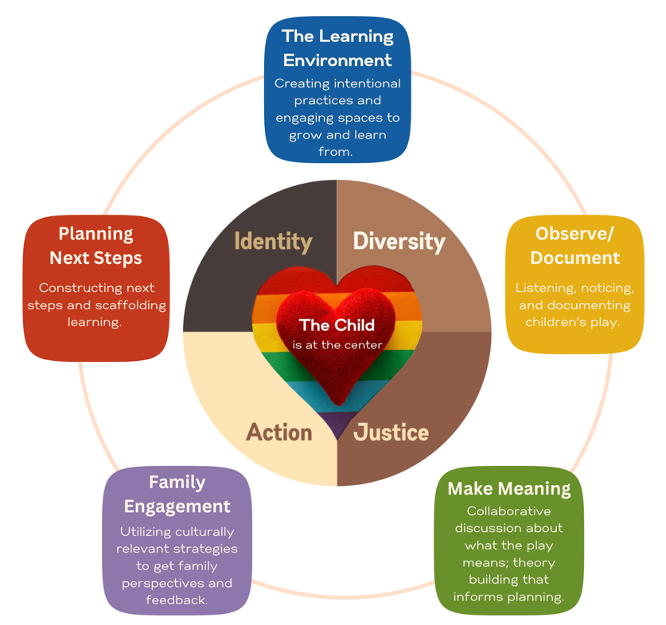

CCRP Goals

Children are highly capable and can construct their own learning. They are driven by their interests to understand and know more.
Children are Forming Identity: Children form an understanding of themselves and their place in the world through their interactions with others. There is a strong focus on social collaboration, working in groups, where each child is an equal participant, having their thoughts and questions valued.
Children are Communicators: Communication is a process, a way of discovering things, asking questions, using language as play. Playing with sounds and rhythm and rhyme; delighting in the process of communicating.
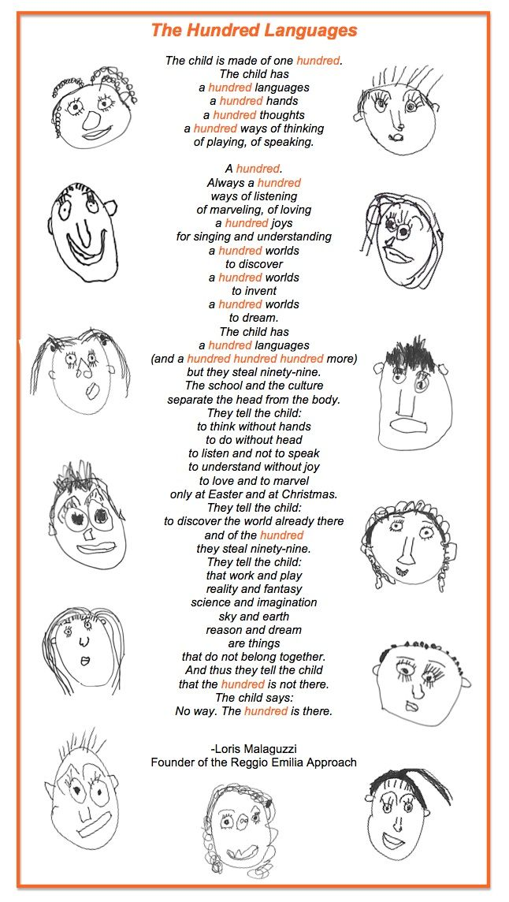
Children are Encouraged to Investigate and Explore, to reflect on their experiences. They are listened to with respect, believing that their questions and observations are an opportunity to learn and search together. It is a process; a continual process. A collaborative process. Rather than the child asking a question and the adult offering the answers, the search is undertaken together.
The Classroom Environment is the Third Teacher (first is family, second is educator): The environment is recognized for its potential to inspire children. An environment filled with natural light, order, and beauty. Open spaces free from clutter, where every material is considered for its purpose, every corner is ever-evolving to encourage children to delve deeper and deeper into their interests. Space encourages collaboration, communication, and exploration. Space respects children as capable by providing them with authentic materials & tools. Space is cared for by the children and the adults.
The Role of Educators: is to observe children, listen to their questions and their stories, find what interests them and then provide them with opportunities to explore these interests further.
Emergent Curriculum/Reggio Inspired: Our approach is child-centered, and teacher supported. Projects aren’t planned in far in advance, they emerge based on the child’s interests and learning urges.
An Emphasis on Documentation: You’ll notice that we are deepening an emphasis on learning documentation of children’s work and progression of thinking (making learning visible in many different ways). Teachers utilize photographs, dictation of children’s thoughts and explanations, visual representations (drawings, sculptures, sketches, etc.), all designed to show the child’s learning process.
The Hundred Languages of Children: Children use many many different ways to show their understanding and express their thoughts and creativity.
A hundred different ways of thinking, of discovering, of learning. Through drawing and sculpting, through dance and movement, through painting and pretend play, through modeling and music, and that each one of these Hundred Languages must be valued and nurtured. These languages, or ways of learning, are all a part of the child. Learning and play are not separate.

Developmental Screening: Ages and Stages

PMCCP provides a family-centered developmental screening tool at the beginning of the school year. The Ages and Stages Questionnaire (ASQ) is highly reliable and valid, looking at developmental strengths and needs. The screening tool incorporates parents’ expert knowledge about their children.

Families are asked to administer this screening at enrollment and the start of each school year. The goals for screening are:
- Partnering with families as experts of their children
- Identifying children's interests and needs
- Describing the developmental progress and learning of children
- Improving curriculum and adapting teaching practices and environment
- Identify a need for further assessment

Ongoing Developmental Assessment
Child assessment is a complex process of observing, recording, and documenting the experiences of individual children – what they do and how they do it over a period of time. “Authentic assessment” means evaluating children’s growth through their daily activities; instead of relying on something that is not a part of their regular routine, such as standardized tests.
Assessment at PMCCP is based on observation and aligned with the Washington Early Learning Guidelines (WELG’s). Observations of children’s behavior and interactions with others help teachers identify children’s learning interests, skills, and strengths, as well as skill sets in need of further development.
Teachers collect and record ongoing observations of children’s behavior and conversations and compile them into individual portfolios for each child. These portfolios contain photographic and written documentation that communicates the unique identity of each child and when viewed over time, provides insights into the child’s growth across the domains of language, physical, cognitive, social and emotional development.
Family conferences are held twice a year to provide an opportunity for families to meet one-on-one with their child’s teachers and to exchange information about the child’s progress. Families participate in the assessment process by sharing their observations of their children’s conversations and behavior at home. These observations help inform the teacher about the child’s accomplishments, likes and dislikes and interpretation of the world.

Guidance and Conflict Resolution

All young children are developing the social skills that enable them to play cooperatively with other children and to function as part of a group. Often when children “misbehave,” it is because they haven’t yet learned the skills to negotiate, to ask for what they need, or to join in play with others, without grabbing, pushing, or hitting. Children are still learning cause and effect regarding how their behavior may impact others.

The ultimate goal of guidance is to help children develop the skills necessary to regulate their own behavior, to be resilient problem-solvers and to understand their own feelings and the feelings of others. In conflicts between children, PMCCP staff facilitate a process that involves assisting children in identifying and expressing their emotions and listening to one another. It also involves helping children generate ideas for a solution to the problem and to decide what course of action to take next. This process will look different depending on the age and skill levels of the children involved in the conflict.

If a child is demonstrating that they are over-stimulated, or are endangering themselves, others or equipment, they will be helped to calm down, be redirected, or asked to engage in a relaxing activity. These instances are used as a time for the child to re-group. They are never used to isolate, shame or punish a child. Ensuring the positive self-esteem of children is at the core of our approach. We know that when children have strong positive attachments to their teachers and friends they are more likely to behave in pro-social ways. Our goal is to help children learn the skills to live respectfully in the community where they feel secure to speak up on behalf of themselves and others.

If a child is unable to gain control and requires more individualized attention than can be given within child to staff ratios, we may need to contact a parent. We work together with teaching teams and specialists as needed to meet the needs of all children in our care. All reasonable attempts will be made to help children be a successful part of classroom activities.

Our goals for children during conflicts are that they:
- Calm themselves down enough to negotiate,
- Find words for their feelings, needs, and wants,
- Listen to others’ feelings, needs, and wants,
- Develop and agree to a mutually satisfying solution and
- Continue to play together, or feel friendly and understanding

In some situations, we may find that we need extra support to help meet a child’s needs. When these situations happen, we will work with the family to take the following steps:
- Meet to share information and ideas for helping the child to thrive and be successful in the classroom.
- After sharing initial observations, teachers and families both will experiment with strategies at school and at home based on children’s strengths, interests and challenges. These may include reviewing and revising the home and/or classroom environment, including expectations, transitions or sleep and meal routines. Families and teachers will select activities and goals to support the child and commit to putting them in place and sharing results.
- Find and share local resources and contact information that might provide support.
- Offer to work in partnership with outside professionals if appropriate.
- If necessary, and only as a last resort, PMCCP may require dis-enrollment and offer to help find a setting that better meets the child’s needs.
We do all of the above while staying rooted in the relationship we have with the family and our care and compassion for the child.
As with all of our practices here, please feel free to ask the director or your child’s teachers for more details on the social problem-solving approach we use at PMCCP.

Family Partnerships

Family Communication
At PMCCP, we strive for clear and open communication between families, staff, and children.

We ask parents/guardians to read all written communications from teachers and PMCCP staff, including posted signs, emails, personal communications, newsletters and to respond when necessary.

We ask families to notify PMCCP in writing of any important changes including contact and permission to pick up information, and the child’s health, attendance, schedule, etc.

Brightwheel: Brightwheel is used daily to check your child in and out the classroom, and for brief updates and reminders as well as emergency notifications. You will be given the information to install the app on your phone.

Email: Email is used as a regular form of communication between PMCCP and families. Please provide PMCCP with your preferred email address and keep us updated if they change. Each classroom has an email list from which the teachers and the director can email families as well. If you do not use email or irregularly check it, please let us know to ensure that hard copies of emails are distributed to you.

Written Communication: Each classroom has a system for written communication between families and teachers, such as ouch reports.

Family Board: Our main entryway has a family bulletin board with resources, event announcements and community connections. In addition, each classroom has a small area for families to get more connected with happens in the classroom. Teachers will schedule conferences twice a year, however, families are encouraged to request time to meet with teachers as needed.

Family Directory: Each family can provide their email address and phone number to be included in a family directory. This directory is available to other PMCCP families – it is meant to be a resource to families in networking with each other. This has been a great tool to share invites to play dates, child-care exchanging or just about anything families would like to connect about.

Family Conferences: Family Conferences are scheduled twice in each calendar year. This is a great time for teachers and families to share their observations, questions and goals.

Translation Services: Dialogue is promoted between families and the PMCCP staff. When language is a barrier to best communicate, PMCCP will access translation services. Only adults will be asked to translate (we will not ask children to do this). PMCCP staff can also translate when applicable.

Classroom Conversations and Confidentiality

While we encourage families to check in with classroom teachers at pick up and drop off. We do ask that conversations be kept brief during classroom hours because teachers are understandably focused on the children and classroom activities. Feel free to arrange a more in-depth opportunity to talk with your child’s teacher, outside of the classroom, if you require more time for a deeper conversation.

To honor confidentiality, we will not engage in conversations about other families or children. If there are any concerns, a meeting by phone or in-person can be arranged.

Visiting / Volunteering in the Classroom

Parents are welcome and encouraged to visit. You do not need to make advance arrangements to visit, although, without pre-arrangement, staff may be unable to spend time in conversation. It is now Washington State law that all classroom volunteers have documentation of Measles vaccination.

When you come in, please explain your presence to your child and let the staff know you are here to visit. Please participate in classroom activities - visitors are welcome to read stories, help with art projects, and assist with puzzles, as well as the other activities. In addition, keep in mind that if your child is experiencing separation anxiety, unexpected visits may heighten their stress.

Commitment to Problem-Solving

If concerns arise, you are asked to let us know so we can begin the problem-solving process. We will work together to find solutions, always keeping the best interest of children in mind. Some differences may be difficult to reconcile, but they must be addressed directly and in a timely manner to ensure the quality of your child's experience at school.

Steps families can take when experiencing a challenging situation with PMCCP staff:

- Talk with the person about your concerns directly.

- PMCCP teachers are dedicated to building partnerships with the families enrolled in our community.
- The best way to ensure that teaching staff is available to hear your concern is to request time away from the classroom to talk.
- It can be overwhelming for teachers to hear family concerns when they are responsible for children.

- If your concerns are still not addressed, then we encourage families to speak to an administrator who can determine and support next steps, meeting with the appropriate staff person or Executive Director.

Confidentiality Policy

The intention of PMCCP’s confidentiality policy is to protect the privacy of children, families and PMCCP staff. We work to ensure that all parents, guardians, and caregivers can share information in the confidence that it will be used to enhance the welfare and education of the children.

- Parents and Guardians have access to the records of their own children but do not have access to information about any other child.
- PMCCP staff will only share information about a child to the child’s parent(s) or guardian(s).
- If PMCCP staff have concerns relating to a child’s personal safety, records are kept in a secure, confidential file and only shared with others on a ‘need to know’ basis.
- Personal information about children, families, and staff are kept in a secure, confidential file.
- Issues to do with the employment of staff, whether paid or unpaid, remain confidential.

Babysitting

We value the professionalism and dedication of our early learning staff. To maintain the highest standards of care and to uphold ethical boundaries, we have a policy that prohibits our child care staff from babysitting for families while they are employed by our organization. This policy is in place to ensure that our staff members can fully focus on their responsibilities within our program and to avoid any potential conflicts of interest. We appreciate your understanding and cooperation in upholding this policy.

PMCCP Staff

Teaching Teams

Your child’s teaching team hosts 3 co-teachers that work together to ensure the best possible educational environment for children. Although your child will have a primary teacher that will lead the communication about your child’s learning, we encourage you to connect with any of the 3 classroom teachers about your child.

PMCCP teachers receive paid planning time each week out of the classroom as well as a weekly team meeting to work on documentation, discuss curriculum, share observations, meet and conference with families and plan curriculum for the children and classroom dynamics.

Community Staff
Nutrition Coordinator: Manages the meal program, serving children in our program breakfast, lunch, and snacks, and ensures that all meals meet the USDA/CACFP requirements. Creates the monthly menu, cooks meals and oversees kitchen management.
Community Teacher: Supports all classrooms by providing coverage and support for teachers who are out sick, on vacation, or need support to plan for conferences, meetings or curriculum documentation. This is a full-time position.
Substitute Teaching: Provides assistance to teams who have a member out sick or on vacation. This is a part-time / on-call position.
Education Coach: Provides training and professional development to teaching staff. Also provides educational events to families throughout the year.

Administrators
Administrative Specialist: Manages monthly tuition billing, general office management, children’s records, and supports fiscal management.
Program Manager: Supervision of teaching staff, , recruitment, manages day-to-day operations
Center Director: Manages enrollment, connects families to social services and educational services, oversees curriculum design, implementation and support, accreditation and quality rating efforts, child-development resources, connections to the early learning community, enrollment, licensing, and other compliance agency partnerships,
Executive Director: Oversees sliding scale applications, provides fiscal oversight, organizational development, and administration, fund development, public relations, budgeting, board relations, directs strategic planning and visioning, including the supervision of administrative staff.

Board of Directors
PMCCP is governed by a volunteer Board of Directors with an executive seat of President, Vice-President, Secretary, and Treasury as well as working committees. Members are nominated and voted in by the current Board members.
The PMCCP Board serves PMCCP by:
1) Ensuring PMCCP’s financial solvency and sustainability
2) Assist in strategic planning
3) Provide support to the Executive Director, including an annual performance review
4) Conduct fundraising activities and attend to fund development.

Non-Discrimination Policy
Pike Market Child Care and Preschool (PMCCP) does not discriminate in our enrollment, hiring practices or in the care of children for any disparity including, but not limited to race, ethnicity, national origin, gender, sexual orientation, age, socio-economic status, religion, differing physical or mental abilities, or communication or learning styles.

We are committed to providing an inclusive and welcome environment. The harassment of others in any form will not be tolerated.

Enrollment & Groupings

Looping: Continuity of Care and Staff Retention
In many early learning programs, children move from classroom to classroom as their skills develop or when they turn a new age. Also, teachers are assigned a classroom and teach there during their length of employment. At PMCCP, we recognize the importance of relationships between teachers and children. With this in mind, we implemented a ‘looping’ system in September of 2002.

Looping is a nontraditional classroom arrangement in which children have the same teacher for two successive years. Essentially, children stay with their peer cohort for their duration of enrollment at PMCCP and at least one teacher will stay with the same group for two years (except for the infant room). That is because there are 3 age groups that teacher’s base their work in: Infants (0-1 years), Toddlers (1-3 years), and Preschoolers (3-5 years)

When teachers have the opportunity to teach the age group that they love, it can significantly contribute to staff retention for several reasons:
- Job Satisfaction: Teaching the age group that aligns with a teacher's passion and expertise can lead to higher job satisfaction. When teachers are working with the age group that they are most passionate about, they are more likely to feel fulfilled in their roles, increasing their overall job satisfaction.
- Reduced Burnout: Teaching a specific age group that teachers are passionate about can help reduce burnout. When educators are genuinely interested in the developmental stages, challenges, and achievements of a particular age group, they are more likely to stay motivated and engaged in their work, thus reducing the risk of burnout.
- Emotional Connection: Teachers who have a strong affinity for a particular age group often develop deeper emotional connections with their students. This emotional bond can lead to a more rewarding teaching experience, fostering a sense of purpose and connection that can help with staff retention.
- Expertise Development: Focusing on a specific age group allows teachers to hone their expertise in that area. As teachers gain more experience working with a particular age group, they become more effective in addressing student needs, implementing age-appropriate teaching methods, and adapting their strategies to best support student learning.
Overall, when teachers have the opportunity to teach the age group that they love, it can enhance their job satisfaction, reduce burnout, strengthen emotional connections with students, and support ongoing professional development. This, in turn, can positively impact staff retention by creating a fulfilling and supportive work environment for educators.

Classroom Groups
The children are cared for in age groups based on when they go to kindergarten. One or more of their teachers will move through the program in 2 looping groups, supporting stronger relationships. Providing 2 ‘looping’ groups allow teachers to specialize in the developmental age that they specialize in.

Since the inception of looping, we have been able to better foster trusting and nurturing relationships between teachers and families. Looping has also been effective in retaining teacher employment. We believe this system gives teachers, children, and families a much greater opportunity to form the kind of bonds that best nurture children and builds a relationship of openness and trust.

Transitions Into a New Looping Group
Each peer cohort moves into their new classroom in September of each year. This allows for greater flexibility so that each classroom can change to fit the developmental needs of the group.
Sweet Peas: Born after August 31 of the school year
Busy Bees: Turn 1 before August 31 of the school year
Blue Skies: Turn 2 before August 31 of the school year
Moon Beams: Turn 3 before August 31 of the school year
Rainbow Birds: Turn 4 before August 31 of the school year
During the transition from one teacher group to the next future teachers will visit the current group to start forming relationships. Current groups will also start taking ‘field trips’ to their new classrooms throughout the month of August. We encourage families to visit the new classroom as often as you can so that you too can become accustomed to the environment and bond with your child’s new teachers. You are encouraged to discuss communication methods that work best for you in order to maintain ongoing dialogue throughout your child’s transition.

Starting School & Separation Anxiety
Transitions are often unsettling for young children. When a child first comes to school, they may be uncomfortable with the new surroundings. Your child may cry or display other signs of unhappiness when being brought to the classroom. Many families find separating from their children difficult as well.

Take heart! This transitional behavior is a way of coping with change and usually disappears in a couple of weeks. Once the child settles into the classroom and gets to know the teachers and the other children, smiles, and laughter take the place of tears.
Another point to remember is that displays of unhappiness are usually confined to the time of separation from the parent. Typically, several minutes after the parent leaves, the child cheers up and gets down to the business of playing and having fun. Please feel free to call and check-in if you are worried about your child’s adjustment. We will connect you with the teachers or check on your child and provide you with an update.
We provide extra ‘TLC’ to help children settle into the classroom routine as soon as possible. We will use all the techniques at our disposal and invite your suggestions for helping your child adjust to school. There are many techniques teachers use to assist with the morning transition, so please check in with your child’s teachers to help develop a morning ritual.

Classroom Ratios
PMCCP serves children 8 weeks to 5 years of age. We strive to meet these these lower NAEYC Teacher/Child Ratios are maintained throughout the day, except for naptime. They are as follows.

Sweet Peas: 1 Teacher to 3 Infants
Busy Bees: 1 Teacher to 6 Young Toddlers
Blue Skies: 1 Teacher to 7 Older Toddlers
Moon Beams: 1 Teacher to 8 Young Preschoolers
Rainbow Birds: 1 Teacher to 9 Older Preschoolers

Transition to Kindergarten
PMCCP assists families in the transition to elementary school. Our staff will share information on public and private schools, help with ideas on how to talk to your child about going to elementary school, and provide information on what to expect.

Transition activities are often implemented to help children such as taking a field trip to a local school or creating a goodbye book to commemorate special friends and times while at PMCCP.

A kindergarten transition meeting will be scheduled during your Rainbow Bird year and will include a panel of PMCCP alumni who will share their experiences regarding their child’s transition to elementary school. The alumni panel will include families who have diverse experiences and they will be able to answer questions.

Our Dedication to Non-Expulsion
PMCCP is committed to providing a nurturing and supportive environment for all children, promoting their emotional, social, and educational development. Recognizing the importance of stability and consistency in the lives of children, we implement a non-expulsion policy to ensure every child remains in our center barring extreme circumstances.

Addressing Complex Needs:
- Prevention: Strategies will be used to prevent behavioral issues before they occur, including positive reinforcement, routine establishment, conflict resolution techniques, and age-appropriate expectations.
- Intervention: Should behavioral issues arise, staff will intervene promptly and effectively, utilizing techniques such as redirection, discussion, and time-ins. More intensive interventions will be tailored to individual needs and circumstances.
- Parental Involvement: Parents will be engaged actively in addressing and managing their child’s behavioral challenges through regular communication, meetings, and cooperative development of behavior modification strategies.
- Professional Support: If necessary, our facility may seek external professional help, such as child psychologists or behavioral therapists, to work with the child and family.

Operating Hours & School Closures

Hours of Operation
PMCCP is open year-round. The center operates Monday through Friday, from 7:45 a.m., and closes promptly at 5:45 p.m.

Holiday Closures
Annual closure calendars with specific dates for the school year are made available for families at the beginning of each school year. Please contact the office if you would like to request a copy.
This is a great way to plan ahead.

We close on the following days:
New Year's Day Martin Luther King Jr. Day
President's Day Memorial Day
Juneteenth Fourth of July
Labor Day Veteran’s Day
Thanksgiving Day & the Day after Thanksgiving Winter Break *Aligned with Seattle Schools.

If a holiday falls on a weekend, we will be closed on either Monday or Friday.

Monthly Early Closures and In-Service Closures
Monthly Early Closures/Staff Meetings: PMCCP closes at 3 pm on the first Wednesday of each month for staff meetings and training. These dates will be marked on our annual closure calendar. Our staff meet monthly as an entire staff for ongoing training to deepen our understanding of children, to solidify our relationships with one another, and to nourish
ourselves for this work. PMCCP’s late pick-up charges will apply after 3:00 pm on these
days.

In-Service Days: PMCCP closes for a weeklong in-service the week before Labor Day. These dates will be marked on our annual closure calendar.

Staff meetings, training and In-Service Days provide an opportunity for staff to work together on program development and training and are part of our commitment to building a cohesive and professional staff. Parents will be given an annual closure calendar to help plan ahead.

Please note that full tuition is due regardless of center closures.

Closure Calendar

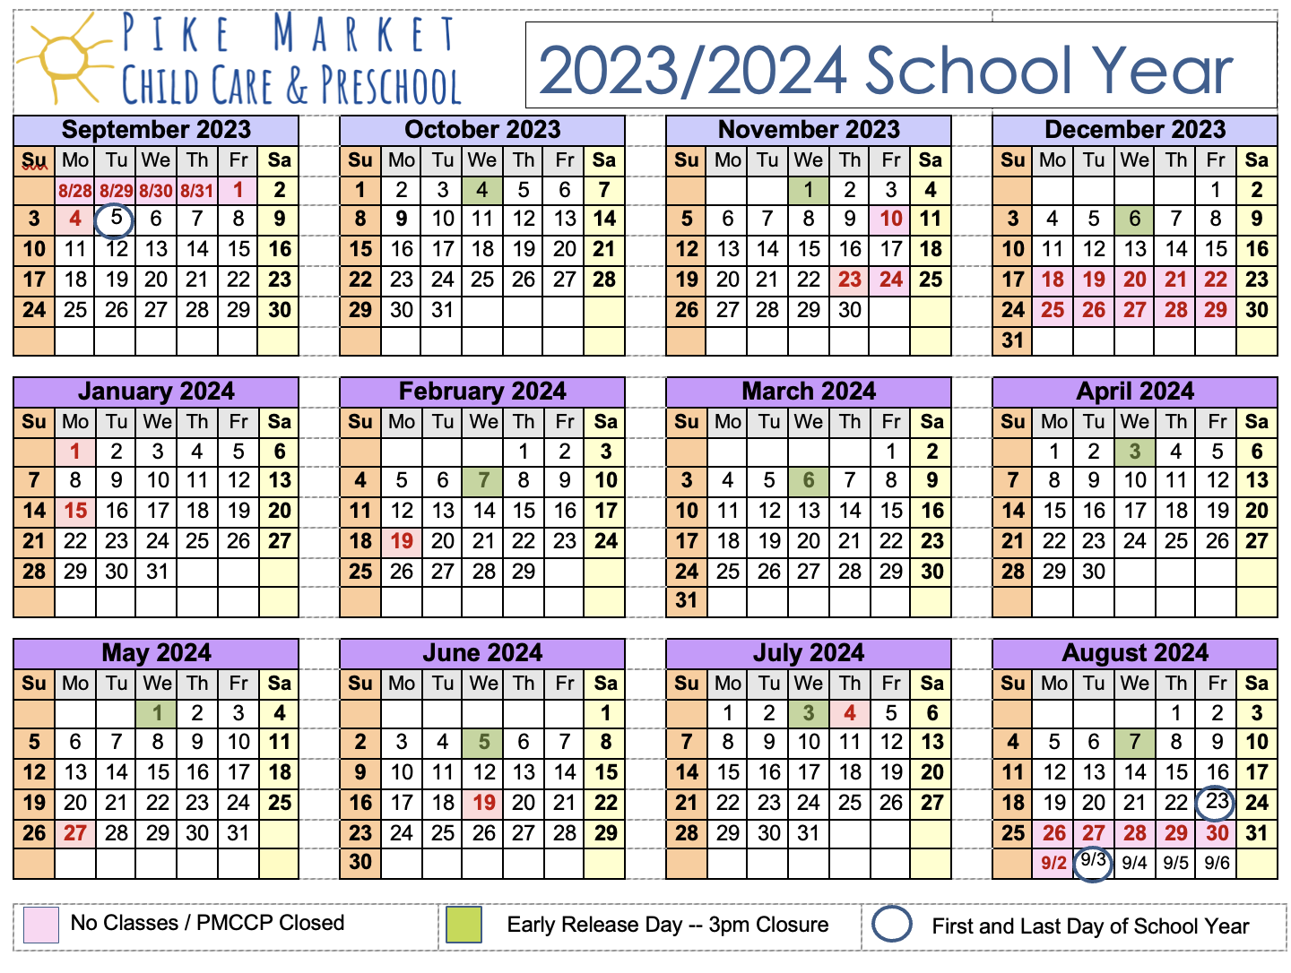

Snow and Inclement Weather

PMCCP strives to accommodate the needs of working families while also valuing the
safety of the children and our staff. We reserve the right to close at any time due to
severe weather conditions or for other emergencies or natural disasters. In general,
PMCCP will close for severe weather whenever the Seattle Public Schools close.

We will close for bad weather or snow whenever Seattle Public Schools is closed. At other times, we may open late or close early, dependent upon developing conditions. When the weather is questionable, we will keep our voice mail message updated with information about our hours of operation. When Seattle Public School is on break, we will look to the METRO bus schedules for guidance. When bus lines are compromised, we will close school for the day.

During times that the public schools are out of session, PMCCP’s closure will be at the
discretion of the Executive Director. No refunds or credits are given for closures due to
inclement weather, emergencies, or natural disasters.

When air quality is poor, teachers will provide large motor activities indoors if the weather, air quality and outdoor environmental safety conditions pose a risk.

In cold weather
- Children should wear clothes that are dry and layered for warmth, and a coat that includes a hood or hat.

In hot weather
- Children have the opportunity to play in shady areas and wear sunscreen for skin protection.
- Consent forms for sunscreen application are signed bi-annually by each family. The sunscreen protection consent forms state the sunscreen used by the center. Sunscreens used by PMCCP contain UVB/UVA protection of SPF 15 or higher and applied to exposed skin.

Dropping Off and Picking Up

Parking
There is a load/unload zone marked on Western Avenue right in front of our North entrance (by the Sweet Pea room). To completely avoid the possibility of a ticket, park across the street from us at Market Parking at 1531 Western Avenue, where currently we can validate for up to ½ hour. To get validation, you must get a feeder parking ticket located in your child’s classroom or in the office. Use this feeder ticket in the exit gate to leave the garage without paying.

Parking Enforcement Officers are quite diligent in downtown Seattle. Read the meter signs very carefully. There are payment kiosks available near open parking spots on the street.

Drop Off by 9:30 am / Pick Up after 2:00 pm
It is ideal for children to be dropped off by 9:30 am as this provides your child with the smoothest and most supportive window of opportunity for drop off. This allows your child to enter into the classroom with enough time to feel welcomed before transitions and more structured activities, projects. Please call if you will be arriving after 9:30 am or if you will be picking up before 2:00 pm so we can try to accommodate your family. It’s especially important to arrive by 9:30 AM on days that outings are scheduled. it is too complicated for teachers to meet up with families outside of the center while out and about in the community with children A typical daily schedule is posted in each classroom. More detailed weekly planning information is posted as well.

We recommend that families refrain from dropping children off during naptime (12:00 to 2:00). Experience has shown that this is a difficult transition time and arrivals during naptime can be unsettling for individual children as well as the group. Additionally, if your child is arriving after our mealtimes, please make sure she/he has eaten before coming to the center.

Sign-In/Sign-Out
Your child must be accompanied to and from school by an adult and signed in and out with the parent/guardian or other authorized adult. This is a Washington State licensing requirement.

Security Doors
All doors to the center are locked from the outside. We ask families and staff to ensure that they do not let unknown people into the center when entering or exiting the classrooms, playground or office. Please ensure that all doors are securely shut. Our entrances have a code that families are given when they enroll. Please contact the office to let us know if you are unable to access the code, or if you notice that the keypad is broken or damaged.

It is our policy that children do not open any doors or gates at school. This includes sharing the security door code with children. This is to ensure the safety of everyone. We expect families to help enforce this rule when in our community.

Who Can Pick Up Your Child

Your child will not be released to anyone without your permission. If someone other than a parent or guardian or those named on the Emergency Contact Form is picking up your child, please email or document. Anyone picking up your child that our staff does not know or recognize will be required to show identification, even if they are on the list.
Identification must be in the form of a picture ID—credit cards, library cards, etc. won’t work.

Please note that the people listed on the Emergency Contact Form are all authorized to pick-up your child at any time. If family circumstances change, please immediately update your Emergency Contact Form. Please make us aware of any special custody arrangements. Special custody arrangements must be documented in your child's file.
Your child will not be released to anyone under the influence of alcohol or drugs.

Late Pick-Up Policy
We do understand that many obstacles can occur that cause your family to be late.
However, it can be distressing for children to be left at school after-hours. In addition, our
hard-working teachers work a long day and expect to leave at closing time. Late pick-ups
are not a normal program option and are considered an exceptional occurrence.

Late pick-up fees of $5.00 per child are payable for each minute your child(ren) remain in
the center after the 5:45 pm closing time. You will be billed for the late pick-up, the
teachers or staff will document the time that your family left the school.

If families are repetitively late, a meeting with the Executive Director will be required to create and document a plan.

When a child is at our center after 5:45 pm, PMCCP staff will:
- Contact the parent/guardian at the numbers provided in the child’s file.
- If contact with parent/guardian is not established, we will call the emergency contact(s) provided in the child’s file and make arrangements for the child to be picked up.
- In the event that the parents/guardians/emergency contact(s) are not available, and it is 7:00 p.m., our staff will need to contact Child Protective Services at 1-800-END-HARM.

Other Program Information

Field Trips
Field trip notices will be posted by email and in the classrooms at least two days before the trip. We ask you to sign the permission form for each field trip. When children go on walks in our Market neighborhood, a note will be posted on the door informing you where they are. No special permissions are necessary for these walks.
PMCCP uses public transit, including light rail, ferry, water taxi, trolley, monorail and metro buses for field trips that require transportation. The notice for field trips will include the mode of transportation (including walks outside of our Market neighborhood). We take many walking field trips.
The Market Neighborhood includes the surrounding neighborhoods around the Pike Place Market that run between 1st Avenue and Alaskan Way, and Union and Lenora.

Holidays at PMCCP
Each child and family is honored at PMCCP, which is why we refrain from celebrating “official” holidays as an institution. Holiday celebrations are not universal. In fact, holidays that have “official” status usually reflect the beliefs, perspectives, and history of the dominant culture. In honoring the diversity of our community, we feel that is important to learn what the various holidays mean to the specific families in our program. A great way for us to begin learning more about your family is by filling out the Home to School Connection of the enrollment packet when you enroll your child.

Families are welcome and invited to share holiday customs that are important to them in our classroom—so check in with your teachers to talk about how we can introduce your customs into our classroom in ways that are developmentally appropriate and culturally relevant. We are hopeful that our approach to holidays is thoughtful, sensitive and patient. Please feel free to let us know your thoughts.

Our program is secular. We do not do religious instruction of any kind.

Costumes and our Non-Violent Philosophy
We have many items at school to dress up/dramatic play and find the children to be more creative when their clothing does not present a pre-determined character. Additionally, we want your children to feel confident, secure, and safe on their feet and in their bodies, so we can provide satisfying outdoor experiences for them.

We work against the bias inherent in many commercial enterprises including movies, (for example - the presented norm that princesses are white with blond hair) as this reinforces false notions that the dominant culture is more valued. Superheroes often provide messages that violence is the way to conquer conflict. These are just a couple of examples of the complex messages that children receive.

From time to time, teachers may invite families to bring children in costumes for “costume day”. Teachers will provide more information and healthy dialogue about these types of events and work to make sure that these “days” are culturally relevant and equitable for all families to participate.

Birthdays and other Parties
We love a good party and recognize that birthdays are special holidays and cultural events for some of our families. However, not all of the families in our community can afford or do not ascribe to commercial gift-giving, so we prefer to celebrate with dance, song, art, and praise. Families, who feel strongly about bringing in gifts to celebrate their child’s birthday at school, are asked to bring in inexpensive items such as small toys, games, stickers, a crafty activity or natural fruit popsicles. Gifts in celebration should be affordable for all families and emphasize caring.

If you plan to include children in your child’s classmates at your in-home birthday parties—we hope that you will include all children in the class as to promote respect and care for each child and family's feelings. If it is not possible to include all families into your celebration, please do not distribute invitations to PMCCP.

Toys from Home
Toys from home should be left at home as they often provoke disputes or hurt feelings and can be lost or broken. We do, however, encourage you to find ways to bring aspects of your home culture into our classrooms. Some examples of this would be donating scarves and textiles to the drama area when you clean out your closet, sharing your child’s favorite book or story, or coming in to do an art or cooking project. Please check-in with teachers about upcoming classroom plans to learn about how your ideas might be included.

Cubbies
Each child has a "cubby" with a coat space and their own basket. Cubbies are used to store nap blankets, "snugglies", a change of clothes, plus treasures your child creates throughout the day. Please check your child's cubby each day for treasures and wet clothes to take home, as well as their supply of extra clothes.

Clothing
All children should come to school in “work clothes” because play is a child’s work. Clothing needs to be comfortable enough for your child to paint, cook, climb and roll in the sand. Children will not be under any kind of pressure from teachers to keep their school clothes clean. Smocks are offered for art projects and water play, and washable paints and markers are used as often as possible, but messes will happen.

Please keep at least one change of clothes for your child in their cubby (more if your child is toilet learning). Accidents happen and children enjoy having their own clothes. Labeling all your child’s clothes will help us reduce the size of our lost-and-found collection.

Fancy accessories, such as necklaces and party shoes, can be dangerous. We ask that your child wear shoes with good traction, such as sneakers, avoiding soles made of hard plastic or leather. Make sure clothing is appropriate for the weather so that your child can play comfortably both indoors and outdoors.

Things to Bring and Have at School
Year-Round
- A blanket for naptime
- A stuffed animal or another comfort object
- A small pillow – if needed for a nap
- 2 pairs of underwear – if your child needs them
- 2 pairs of socks
- 2 pairs of pants
- 2 shirts
- Diapers – if your child still uses them

In the Wintertime…
- A warm hat
- Gloves or mittens
- A raincoat
- Winter Coat
- Rubber boots

In the summertime….
- A bathing suit or clothes to splash in the water
- Water shoes or shoes that can get wet

Blankets and Snugglies
Please make sure your child has her own blanket for naptime and a small pillow if desired. These will be kept in her cubby and labeling them assists staff. We ask that you take your child’s blanket home each week to wash. Children may have one item such as a stuffed animal to snuggle with at nap.

Diapers and Toilet Learning
We honor each child’s individual process and believe that children can only be toilet trained when they are ready. We find that children often become interested in using the toilet as they experience their peers using the toilet and will ask them if they are interested in trying it periodically. We will work with parents for consistency. Please keep in touch with staff about changes and progress at home as well as what your hopes and methods are. It also helps us to know what language your family uses, including words for urine, feces and body parts.

Families are required to bring in diapers for their child; we will provide wipes. Children in diapers will be checked & changed regularly. If your child needs any ointments, we require you to supply the diaper ointment and fill out a diaper ointment consent form. All ointments will be labeled and kept isolated with your child’s diaper supply.

Meal Program

Meals & Snacks

PMCCP provides breakfast, lunch, afternoon snack and a light, late afternoon snack for children who are still at school later in our school day. PMCCP provides organic cow’s milk, soy milk or rice milk for children ages 2-5 and organic whole milk for children 1 year to 2 years old. All meals and snacks are prepared in our on-site kitchen by our Nutrition Coordinator.

PMCCP is a participant of the USDA Food Program and follows criteria established by the United States Department of Agriculture. Each family is asked to complete an Income Eligibility form each Fall, whether or not the family’s income meets the program criteria. PMCCP’s food program is available to all children regardless of race, color, ability, sex or national origin.

Menu
Our menu is designed to be delicious and nutritious. We use little or no- sugar, and provide whole grains, and fresh fruits and vegetables daily. We enjoy learning what your family eats at home and encourage you to share your family favorites via class projects and/or recipe swaps with our staff.
Menus are posted each month and the daily menu items are posted by the kitchen as well as the main entrance. Many families stop to review – “what’s for lunch today?” before heading into the classrooms.

Family Style Dining
Meals are served ‘family style’, where children eat in small groups with a teacher. This is an excellent forum for children to gain social skills. Children also learn self-help skills as they help serve the food, clean up and compost. While children are encouraged to eat and are offered all components of the meal, they are never required to take or try any foods. Food is never used as a behavior incentive (a reward) or punishment.

Eating food with children is as important as any other time of day in a child’s life. Children learn life-long habits and develop relationships with food and their bodies during meal times. It is our goal that lunch will be a relaxed and conversational time for children and teachers to visit and enjoy their food. We will encourage children to try what’s on their plates at least twice but will not insist that children eat everything. Research tells us that children can learn to listen to their bodies if they are given healthy foods from which to choose and are not forced to eat them. We believe that this is how children learn to trust cues from their bodies about hunger and fullness.

Families who bring children to school after meal service has ended should provide a meal for their children prior to arriving at PMCCP.

Diet Restrictions
If your child has specific dietary requirements, such as food allergies, religious exemptions or dietary preferences, we will work with you to meet your child’s nutrition needs. Meals will be adjusted where possible; otherwise, families must provide food alternatives.

Because we partner with CACFP/USDA to provide financial assistance for our meals, a signature from your child’s health care physician will be necessary to have on file in order to order to provide alternatives from our kitchen. Please contact our office for assistance in obtaining the necessary paperwork.

Food and Drinks from Home
Only families that have a written plan for bringing alternative foods should be bringing outside foods. If your child is not on a meal plan, please refrain from bringing any outside drinks and foods to school. We have several children with severe food allergies, and it is much easier to regulate when we know exactly which foods are being offered at school!

PMCCP is Peanut and Tree-Nut Free due to extreme allergic reactions. Our kitchen and classrooms are also currently egg-free. If you are on a written plan to bring alternative food in or are participating in a potluck or cooking activity -- please be sure to exclude Peanut Butter, nuts of any kind or eggs in any dishes or ingredients.

Vegan and Strict Diets
If your child is vegan or has a strict diet, PMCCP will work with you to create a plan. We try our best to adapt our menus to meet everyone’s needs—but for specific menu items, we may ask families to provide alternative menu items.

Cooking Projects
Teachers (who are familiar with all of the special diets in their classrooms) will continue to do cooking projects that are safe and healthy for all of the children to participate in. If you would like to do a special project or celebration in the classroom, make sure to plan it with teachers including all ingredients for the project prior to the activity time.

Tuition and Fees

Tuition Fees
Tuition is set annually in September. The monthly cost is 12 equal payments for the year. Tuition is due on the 1st of each month, and late fees apply after the 10th of the month. All payments are made electronically via debit, credit, or EFT. Please let us know if another form of payment is required.

Families who qualify for sliding scale tuition and/or who use vouchers or subsidies towards their tuition are responsible for providing accurate documentation and maintaining eligibility through the state, county, or city program, and for paying any balance required by the sponsoring agency or PMCCP.

Monthly tuition rates are not adjusted for the number of school days or school closures in a particular month. Tuition cannot be suspended or adjusted due to absences. PMCCP reserves the right to increase tuition at any time based on the financial need of the school. If an increase in tuition becomes necessary, all families will receive notification 30 days prior to the increase.

Late Payment Fees and Financial Emergencies
Tuition is due by the 1st of each month. Payments made after the 10th of the month will receive a $25 late payment fee. If your family has a financial emergency or change in financial circumstance you will be asked to meet with the Resource Coordinator at the Commons to determine eligibility for other forms of assistance within the first month of a late payment. We reserve the right to suspend your child’s participation in in the program if your account is past due.

Receipts and Taxes
Monthly receipts for tuition payments and year-end documentation of child care expenses are available upon request. We encourage you to investigate all possible tax credits and ask you to consider donating a portion of any savings from tax credits to our scholarship program.

Our Tax ID is 91-1148078.

Late Pick-Up Charges
Please arrive with enough time to reunite with your child, gather their belongings and sign out by our closing time at 5:45 pm. This helps our staff rely on a consistent schedule, and ensures that your child isn’t worried about your arrival.

Late pick-up fees of $5.00 per child are payable for each minute your child(ren) remain in
the center after the 5:45 pm closing time. You will be billed for the late pick-up, the
teachers or staff will document the time that your family left the school.

If families are repetitively late, a meeting with the Executive Director will be required to create and document a plan.

When a child is at our center after 5:45 pm, PMCCP staff will:
- Contact the parent/guardian at the numbers provided in the child’s file.
- If contact with parent/guardian is not established, we will call the emergency contact(s) provided in the child’s file and make arrangements for the child to be picked up.
- In the event that the parents/guardians/emergency contact(s) are not available, and it is 7:00 p.m., our staff will need to contact Child Protective Services at 1-800-END-HARM.

Giving Notice / Leaving PMCCP
We require one month’s written notice of your intent to leave our center. If you should leave with less than one month’s notice, you will be charged for the time difference.

Saying Goodbye: We believe children form deep attachments with their school community and that sudden or unacknowledged departures can be sad and confusing. Please inform your child’s teacher of your intent to exit, with specifics about when and what you will be telling your child about their departure. This allows us to be sensitive to your child as well as to help all the children make the transition.

Full Cost of Care, Sliding Scale, Subsidies & Vouchers
The mission of PMCCP is to make high quality early learning accessible to all families, regardless of income. High quality early learning means that at PMCCP class sizes are smaller, student to teacher ratios are lower, and teachers earn equitable living wages, full benefits and professional development.

Our practice is that every year 50-70% of families that are enrolled qualify for a scale and/or subsidy. Fees are determined by income and family size, as indicated on our sliding fee scale. Two forms of documentation of income must be provided, before enrollment and annually. Acceptable forms of documentation include a copy of your most recent tax return and either three months of pay stubs, the previous year’s tax return or a letter from your employer stating your gross wages.

Full Cost of Care, Sliding Scale, Subsidies & Vouchers
The mission of PMCCP is to make high quality early learning accessible to all families, regardless of income. High quality early learning means that at PMCCP class sizes are smaller, student to teacher ratios are lower, and teachers earn equitable living wages, full benefits and professional development.

Our practice is that every year 50-70% of families that are enrolled qualify for a scale and/or subsidy. Fees are determined by income and family size, as indicated on our sliding fee scale. Two forms of documentation of income must be provided, before enrollment and annually. Acceptable forms of documentation include a copy of your most recent tax return and either three months of pay stubs, the previous year’s tax return or a letter from your employer stating your gross wages.

PMCCP Monthly Tuition Rates for 2023/2024

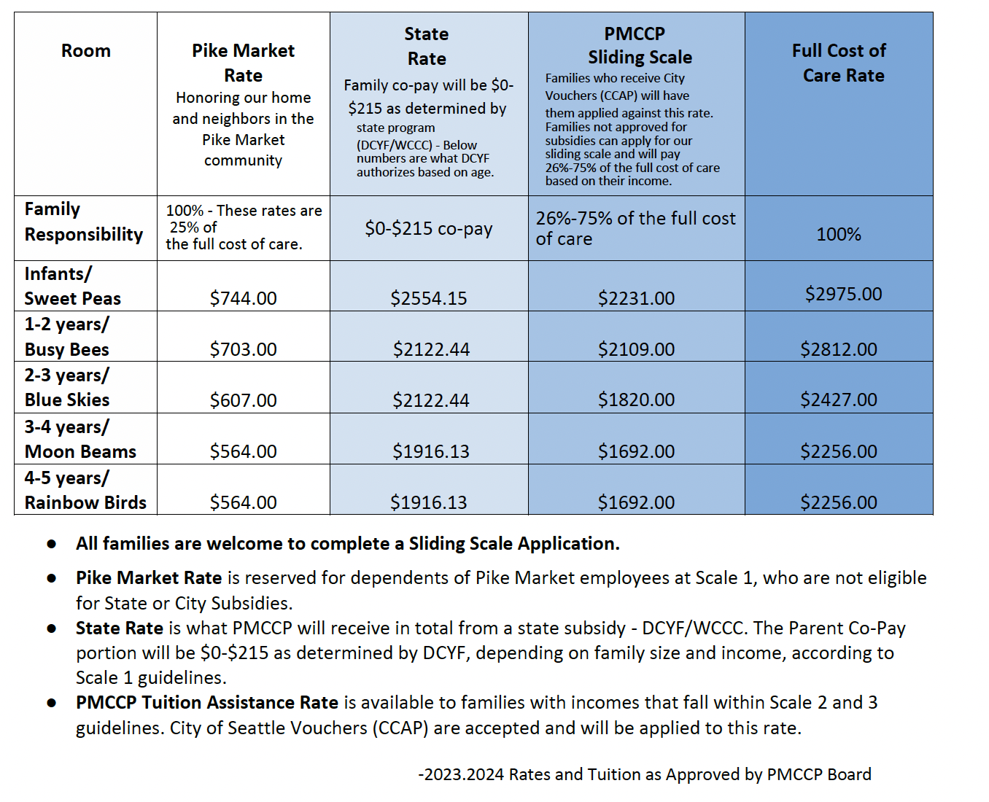

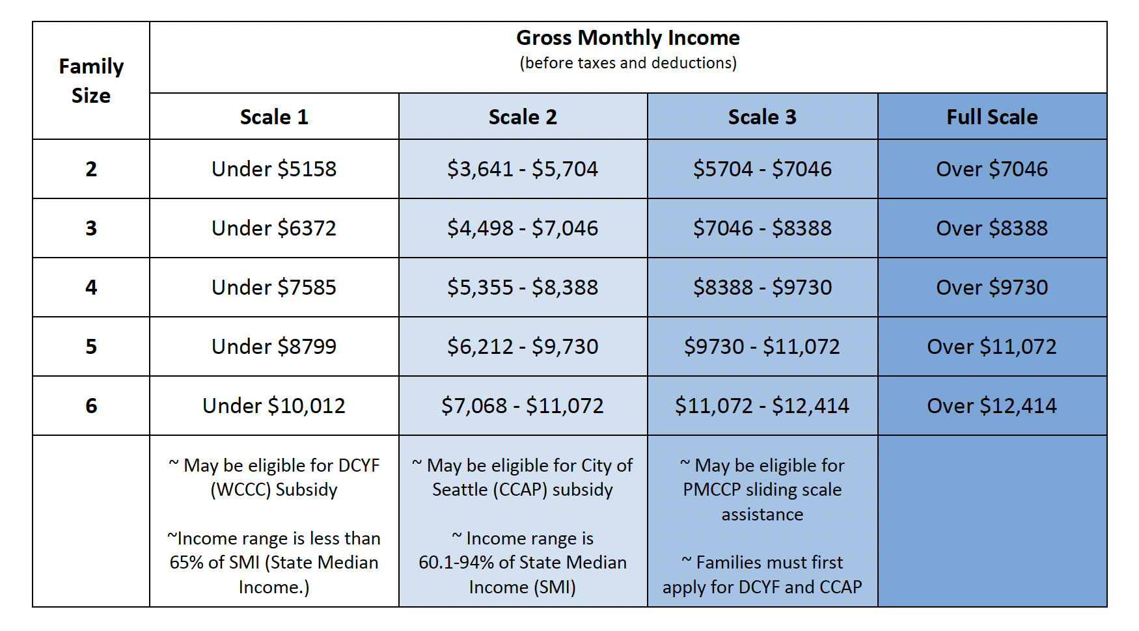

Health Policies

Immunizations and Health Exams

State law requires a health history and record of immunizations for each child prior to admission. We are also required to have the date of your child’s last physical exam, which must have been completed within one year prior to admission. We ask for the name and address of the family physician and dentist, who to contact in case of an emergency, and any conditions of the child which may require specific attention.

Children must have all immunizations that are recommended for their age by the State of Washington. A licensed physician may grant medical exemptions to immunizations; personal or religious exemptions can be claimed by parents/guardians. In the event that your child is not immunized against a particular disease and an outbreak of that disease occurs, your child may be excluded from care. PMCCP is required to have a doctor’s signature on all exemption forms.

Each year we are required to file an immunization report with the state. At the end of each school year, we will send out a form asking for updates of your child’s immunizations records. Your cooperation in doing this is greatly appreciated and will be facilitated if you keep a record of immunizations in a safe place. King County Department of Health provides free immunizations for children.

Illness
A day at PMCCP is easy and fun for a child in good health, but exceedingly demanding for one who is not feeling well. Sick children need one-on-one care and unlimited rest and fluids that they can get at home. Bringing a sick child to school exposes him/her to other secondary illnesses and exposes the staff and other children to illness. Bringing a child back to school before all symptoms have subsided risks a relapse and further delays recovery.

While we know how inconvenient it can be for a parent or guardian to have to miss work or school to stay home with a sick child, we have a responsibility to maintain a healthy environment for all for our children, families, and staff. Families whose work schedules do not allow them to stay at home with a sick child will want to have options for the inevitable day when their child will be excluded from care.

Public Health of King County issues the following guidelines on keeping children home, which PMCCP adheres to. Children who show signs of illness as follows should not be brought to school.

- Vomiting, two or more times in 24 hours.
- 2 loose/watery stools in 24 hours
- Body rash (not related to an allergic reaction, diapering, or heat), oozing open sores or wounds, mouth sores with drooling, untreated head lice, ringworm or scabies
- A fever of 101 degrees F or higher and have a sore throat, earache, headache, rash, vomit, diarrhea, or just not feeling well
- Unusually tired, low activity level, pale, lack of appetite, cranky, or crying more than normal

Refer to the Washington Administrative Code (WAC) 110-300-0205 for the licensing guidance and complete exclusion requirements.

Communicable Diseases/Illnesses
Children who are contagious must stay at home until they are no longer contagious. The Health Department will be notified of communicable diseases as per their reporting requirements. We try to keep parents informed of outbreaks of illness to help you in the care of your child. Please inform the center of any communicable diseases/illnesses.

Calling Out Absences
Please call us if your child will be absent for any reason, but especially if it is due to illness, so we can be on the lookout for similar symptoms other children might be experiencing.

If teachers, or other program staff, have concerns about a child's readiness to be in our care after an illness, we may request a note from your child's health care provider.

CPR and First Aid
When children are in our care, staff with current Cardio-Pulmonary Resuscitation (CPR) and First Aid, are always available. First Aid kits are in each classroom and are taken on all adventures away from the center (even to the playground).

Minor cuts, bruises, sprains or bumps will be treated on-site by a staff member trained in First Aid. The guidelines in the Seattle-King County Department of Public Health Child Care Health Handbook will be followed. You will receive an "ouch" report explaining injuries and their treatment.

Medicine Management
Medication will be given only with the prior written consent of the child's parent/legal guardian. An "Instruction for Medication" form must be completed.

Prescription medications must be in the original container from the pharmacy and labeled with:
- Child's first and last name
- Medication name
- Dosage amount
- Frequency
- Length of time of treatment (e.g., number of days)

We will give a child non-prescription medication only when:
- The medication is in its original container, and
- The dose and frequency is stated on the label, and
- The medication is age-appropriate for your child. (If your child is younger than the ages recommended on the label, we require written consent from you and a health care provider legally authorized to prescribe medicine.)

If your child needs to have medication administered, please inform a teacher when you bring them to the center. You must fill out an Instruction for the Medication form, giving us permission and instructions. DO NOT LEAVE MEDICATION IN YOUR CHILD’S CUBBY OR BACKPACK. Give the medication and the completed Instruction for Medication form to a staff member.

Incident Reporting

If injury results in outside medical treatment or hospitalization, we are required to notify our Department of Social and Health Services licenser and to submit an "Injury/Incident Report". You will be given a copy.

Child Abuse Reporting

All employees are mandated reporters.
All childcare staff are required by mandatory reporting laws to report to the Department of Social and Health Services and Child Protective Services any suspected child abuse, neglect, or exploitation. Our staff receives training in the law and in respectful ways of identifying and reporting. We are not required to notify parents. If you have any questions or concerns about this, please ask.

Biting

Biting occurs most often among toddlers (13 to 24 months old) and should be considered “normal" behavior. Toddlers use their mouth as a tool for exploring their world. They are learning to tell the difference between food and non-food items. Many of their teeth are in and they are starting to use words for the first time. Toddlers who bite may be trying to get a point across when they don't expect their words to work, or they may simply be expressing frustration. When biting happens, it can be scary, frustrating and stressful for children, parents, and teachers. Sometimes there isn’t a quick or easy solution to biting, but looking at why young children bite is essential to addressing the issue.

Children bite for a variety of reasons; simple sensory exploration, panic, feeling crowded, seeking to be noticed or desire for a toy. Toddler teachers work to reduce the risk of biting by creating a calm and caring environment. Classroom activities should be developmentally appropriate and include several of each favorite toy. Overstimulation because of overcrowded spaces or high noise levels can contribute to stress in children and increase biting. One study found most bites occur early in the day and late in the afternoon. Children may be especially tired at these times and lose some self-control. Young children should be watched for signs of tiredness and restful activities planned.

When children bite at PMCCP:
Occasional or first-time biters should be treated in a calm and caring manner. We will attend to the needs of the child who was bitten. We will let the biter know that we understand he was trying to say something to his friend. The situation is eased by showing the child how people should treat each other. For example, a teacher can enlist the biter's help in caring for the injured child. Teachers should note the details of the incident in order to discover what may have motivated the child to bite. For example, does the child appear stressed, angry, or sad? Is there a time of day or activity when biting occurs most often? An ouch report will be given to the victim’s family and the biter’s family will also be notified.

We will develop a plan with our Public Health Nurse if biting persists:
- The child seems surprised that biting hurts their friends.
- The child bites the same person repeatedly.
- The child bites frequently and seems unhappy.

The name of the biting child is not released (please review our Confidentiality Policy). We will make every effort to extinguish biting behavior quickly and to provide support to families. Only after we feel we have made every effort to make the program work for the biting child do we consider asking their family to withdraw from our program.

Emergency & Disaster Plans

Our plan is available to all families by visiting our website: www.pikemarketkids.org/resources

Since 1982, PMCCP has been providing safe and nurturing care for young children. We have a comprehensive Crisis and Disaster Plan in place and all faculty receive training in this plan. This includes building and site evacuation, earthquake preparedness, emergency lockdown/intruder alert, fire safety, power outage, storms and snow, and other such emergencies that could occur.

As required by licensing, faculty and children practice monthly fire and quarterly disaster drills so that this becomes a routine, non-threatening occurrence for the children. Additionally, all of our staff are trained in CPR/First Aid and Blood Borne Pathogens. We have 72 hours of food and water on site as recommended by disaster specialists.

Facts about PMCCP

Access
Founded on the idea that all children deserve access to high-quality care, PMCCP typically provides tuition assistance to 70% of enrolled families. We have created an inclusive and culturally, linguistically and socio-economically diverse community that affirms families of many forms.

Fundraising
To provide tuition assistance we rely heavily upon the support of our community. The Pike Market merchants, and employees, craftspeople, operational staff, and residents have been vital to our success. Families, board members, and friends, literally throughout the world, give us gifts of time, money, and inspiration. The Market Foundation and the Pike Place Market Preservation and Development Authority provide both financial support and advice to us as part of their commitment to serving the low-income and elderly residents in downtown Seattle. Other fundraising activities include grant writing, special events, workplace giving and corporate contributions. We work constantly to raise funds to ensure equity of access to families of all income levels at PMCCP. We welcome parent involvement on the Fund Development committee.

Program Goals
The goal of our program is to provide all children the same access to quality child care and pre-school, healthy meals and family support, regardless of family income or circumstances. The result is that families in our program have the opportunity to seek work and/or go to school with the knowledge that their children will receive healthy meals, excellent care and the social and learning skills necessary to succeed in kindergarten and beyond.

Worthy Wages for Early Childhood Educators

Pike Market Child Care & Preschool has a history of commitment to "Worthy Wages", which recognizes the direct correlation between worthy compensation for child care workers and the quality of child care provided. We support Worthy Wages by providing salary and benefits packages that are among the most progressive for child care workers. Although this naturally increases the cost of care, the hard work, dedication, and professionalism of our staff merit every bit of compensation we can provide.

Ways Families Can Help…

Pike Market Child Care & Preschool is proud of our commitment to providing a high-quality child care experience to families of all economic means. This commitment to opening our doors wide has added depth to our program and has enriched children's life experiences.
You are part of the community that we rely on to make our work possible. As a member of our community, you will be asked to help us in several ways such as:

Workplace Giving Campaigns
Please let the Executive Director know if your workplace has a giving program for employees. We’d love to introduce the work of PMCCP to your workplace to encourage support and contributions from other employees. Many parents support our tuition assistance program by making a designated donation through their workplace. You may make a designated gift to PMCCP through United Way and the City, State, Metro & Port of Seattle campaigns. You may also give to us through the Coalition for Charitable Choice.

Individual Support
Of course, we also welcome personal donations, and some parents even choose to make a monthly contribution by including a recurring monthly or annual donation. If your employer matches gifts, the strength of your contribution multiplies.

Fundraising Events
Annually, we hold fundraising events to raise money for our tuition assistance program and high-quality program. You can help by serving as a classroom coordinator, securing sponsorships, collecting pledges from friends, family & co-workers, starting a team or just coming out and showing your support on the day of the event. We also appreciate volunteer help on the day before and day of the event.

All families are invited and encouraged to attend our events. Families play a major role in raising awareness about the important services that PMCCP provides our community.

